1. Creating and Renaming Files/Directories

Create a directory named test_dir using mkdir.

Inside test_dir, create an empty file called example.txt.

Rename example.txt to renamed_example.txt using mv  
**Explanation:**  
The mkdir command is used to create a new directory named **test_dir**.  
Then, by using cd test_dir, we move inside that directory to work within it.  
The touch example.txt command creates an empty file named **example.txt** inside the directory.  
Finally, the mv example.txt renamed_example.txt command renames the file to **renamed_example.txt**.  
The mv command can also be used to move files between directories, but in this case, it is used to rename.

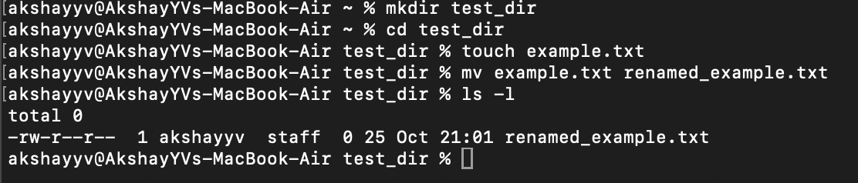

2. Viewing File Contents

Use cat to display the contents of /etc/passwd.

Display only the first 5 lines of /etc/passwd using head.

Display only the last 5 lines of /etc/passwd using tail.  
**Explanation:**  
The /etc/passwd file contains user account information for all users on the Linux system.

* The command cat /etc/passwd displays the entire contents of this file at once.
* The command head -n 5 /etc/passwd shows only the **first 5 lines** of the file, which is useful when you just need to preview its beginning.
* The command tail -n 5 /etc/passwd shows the **last 5 lines**, helping to check the most recent entries in the file.  
  These commands are commonly used to quickly inspect text files or configuration files.

3.Searching for Patterns

Use grep to find all lines containing the word "root" in /etc/passwd.  
**Explanation:**  
The grep command is used for searching specific text patterns within files.  
By running grep "root" /etc/passwd, the command searches for every line that contains the word **"root"** in the /etc/passwd file.  
It then prints only the matching lines to the terminal.  
This is useful for filtering information from large text files, such as log files or system configuration files.

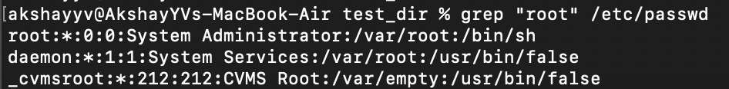

4. Zipping and Unzipping

Compress the test_dir directory into a file named test_dir.zip using zip.

Unzip test_dir.zip into a new directory named unzipped_dir.  
**Explanation:**  
The command zip -r test_dir.zip test_dir compresses the entire **test_dir** folder (and all files inside it) into a zip archive named **test_dir.zip**.  
The -r flag stands for “recursive,” meaning it includes all subdirectories and files within the folder.  
To extract the contents, the command unzip test_dir.zip -d unzipped_dir is used, which creates a new folder named **unzipped_dir** and extracts the contents of the zip file into it.  
This process is useful for sharing, archiving, or backing up directories efficiently.

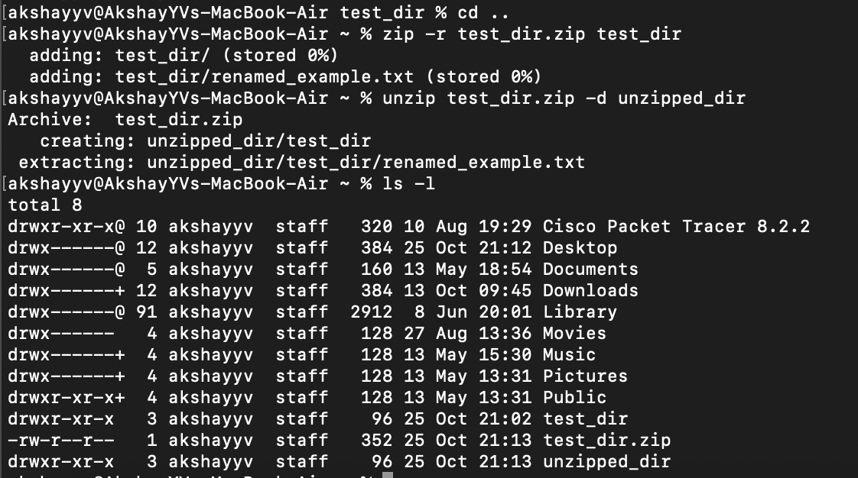

5. Downloading Files

Use wget to download a file from a URL (e.g., https://example.com/sample.txt).  
**Explanation:**  
The wget command is used to download files from the internet directly through the terminal.  
By running wget https://www.learningcontainer.com/wp-content/uploads/2020/04/sample-text-file.txt, it connects to the given URL and saves the file in the current directory.  
If the server is reachable and the file exists, it will be downloaded successfully and displayed with a confirmation message.  
You can use ls -l to verify that the file has been downloaded.  
This is often used in scripting and automation for fetching data, documents, or software packages.

6. Changing Permissions

Create a file named secure.txt and change its permissions to read-only for everyone using chmod.  
**Explanation:**  
The touch secure.txt command creates a new file named **secure.txt**.  
Then, the command chmod 444 secure.txt changes the file’s permission to **read-only** for everyone — meaning no user can modify or delete it without first changing permissions again.  
In Linux permission notation, 4 stands for **read**, 2 for **write**, and 1 for **execute**.  
Thus, 444 sets read-only permissions for the owner, group, and others.  
You can confirm the change using ls -l secure.txt, which will display -r--r--r-- as the permission string.

7. Working with Environment Variables

Use export to set a new environment variable called MY_VAR with the value "Hello, Linux!".  
**Explanation:**  
The export command in Linux is used to create and assign values to environment variables.  
By running export MY_VAR="Hello, Linux!", a new environment variable named **MY_VAR** is created and assigned the value “Hello, Linux!”.  
The command echo $MY_VAR displays the value of this variable.  
Environment variables are temporary settings stored in memory and are often used to configure software, store session-specific data, or control system behavior.  
In this example, the variable will exist only until the terminal session is closed.



Submission Guidelines -: Attach Screenshots or command along with explanation and submit in doc(google doc or microsoft doc) format also attach github repo link